Round 1 Playoff Preview: What the Data Says About All 16 Teams

New here? Start with the foundation post — The Geometry of Winning — which explains the framework behind these predictions.
ASH GARG L HOCKEYROI
APR 20, 2026
Six seasons of NHL shot data plus power play and penalty kill metrics. A three-pillar model that predicts playoff qualification with 86% accuracy on holdout data.
I posted the results on X before the playoffs started.
Here’s what it says about Round 1.

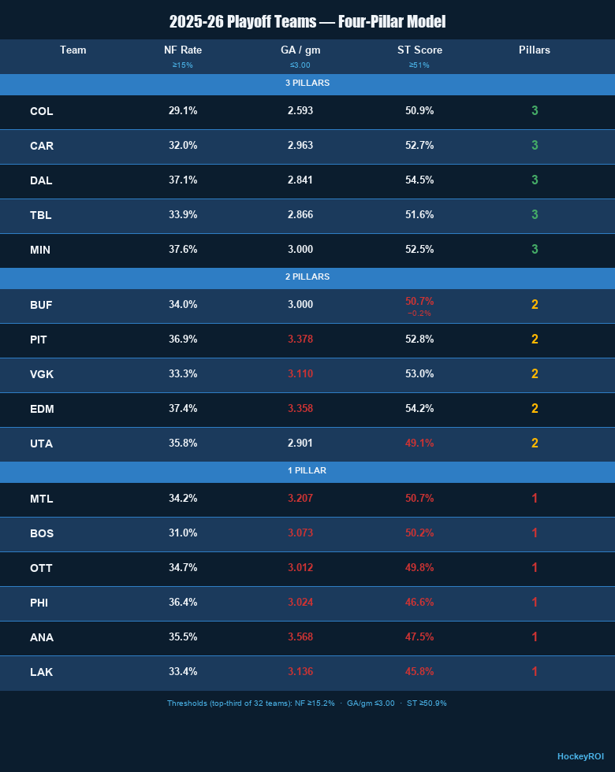

All 16 playoff teams ranked by pillar count. Green = pillar met, red = pillar missed. Gold team name = model pick to advance.

The Three Pillars
Net-front attempt rate — how often a team generates tip-ins, deflections, and rebound attempts as a percentage of even strength shots. Threshold: top third of the league (≥15.2%).
Goals against per game — the single strongest predictor in the dataset. Captures both defensive structure and goaltending quality in a single number. Teams with poor goaltending show up here regardless of how well their defense plays. Threshold: ≤3.00 goals against per game. I will dive deeper here in future post to find what individual metrics leads to a low GAA.
Special teams score — the average of power play percentage and penalty kill percentage. Correlates with winning more strongly than any single even strength metric except goals against. Threshold: top third of the league (≥50.9%).
A note on special teams: We can model the outcomes but not the underlying driver. We believe PP and PK effectiveness is primarily driven by acceleration in tight spaces — first-step quickness in puck battles under one metre. The NHL has not made that data publicly available. Until it is we’re measuring what special teams produces, not what causes it. I will also dive deeper to see if I can find other correlations.
Five teams meet all three pillars this year. Zero teams meet zero — every playoff team has at least one strength.

THE EASTERN CONFERENCE

Buffalo vs Boston
Buffalo is a two-pillar team that barely misses a third — their special teams score of 50.7% falls 0.15 percentage points below the threshold. In practice they’re as complete as any three-pillar team in the field. Net-front rate of 34.0% is among the highest in the playoff field. Goals against of exactly 3.000 clears the threshold.
Boston meets one pillar — net-front rate at 31.0%. Their goals against (3.073) and special teams (50.2%) both fall short. They’re a team with offensive net-front instincts but defensive and special teams vulnerabilities the model can’t ignore.
Model pick: Buffalo — High confidence

Tampa Bay vs Montreal
Tampa meets all three pillars — net-front rate (33.9%), goals against (2.866), special teams (51.6%). Montreal meets one — net-front rate at 34.2%, but goals against of 3.207 and special teams of 50.7% both fall short.
Montreal’s .646 points percentage is the biggest anomaly in the dataset — a strong regular season record despite failing two pillars. That kind of overperformance relative to underlying metrics typically regresses. Tampa’s Cirelli and Guentzel are legitimate Tier 1 net-front players with elite trajectory. Their system is built around exactly what the model values.
Model pick: Tampa Bay — High confidence

Carolina vs Ottawa
Carolina meets all three pillars — net-front rate (32.0%), goals against (2.963), special teams (52.7%). Ottawa meets one — net-front rate only at 34.7%, with goals against of 3.012 and special teams of 49.8% both falling below threshold.
Carolina’s defensive advantage is the decisive factor. Their forwards generate the fewest rush chances against of any team in the dataset across multiple seasons. Stankoven, Aho, Kotkaniemi, Blake — the system has been elite at preventing transition chances consistently. Ottawa is dangerous and young but Carolina’s system maturity is the edge.
Model pick: Carolina — Medium confidence
This goes six or seven games.

Pittsburgh vs Philadelphia
Pittsburgh meets two pillars — net-front rate (36.9%) and special teams (52.8%). Goals against of 3.378 is the weakness. Philadelphia meets one pillar — net-front rate only at 36.4%, with goals against of 3.024 and special teams of 46.6% both falling short.
In a series between two incomplete teams, net-front personnel and special teams decide it. Mantha (CI-confirmed elite), Rust, and Crosby give Pittsburgh three Tier 1 net-front forwards. Philadelphia’s Noah Cates is their only confirmed Tier 1 player. Pittsburgh’s special teams edge (52.8% vs 46.6%) is the largest gap in any Eastern matchup.
Model pick: Pittsburgh — Medium confidence

THE WESTERN CONFERENCE

Colorado vs Los Angeles
Colorado is the model’s most interesting team. They rank 21st in net-front attempt rate among all playoff teams — lowest of any three-pillar team. Yet they have five of the top net-front forwards in the league by career composite: Nichushkin, Lehkonen, Nelson, MacKinnon, and Rantanen. Best even strength save percentage in the league. Best goals against in the league. Special teams at 50.9% clears the threshold by the thinnest margin.
The story isn’t volume — it’s quality. When Colorado’s elite net-front forwards get to the doorstep they convert at above-average rates. The system doesn’t send them there on every shift. It sends them there when it counts.
LA meets one pillar — net-front rate at 33.4%. Goals against of 3.136 and special teams of 45.8% — the worst in the playoff field — both fall well below threshold.
Model pick: Colorado — High confidence

Dallas vs Minnesota
The best first-round matchup in the playoffs by the model. Two three-pillar teams meeting in Round 1.
Dallas — net-front rate (37.1%), goals against (2.841), special teams (54.5%, highest in the playoff field). The most complete team in the West. They acquired Bunting at the deadline — the player this model identified as the best available net-front forward on the market. Robertson is CI-confirmed elite on the two-way composite.
Minnesota — net-front rate (37.6%), goals against (exactly 3.000), special teams (52.5%). Eriksson Ek and Tarasenko are legitimate Tier 1 net-front players. Their system is built similarly to Dallas’s but with slightly less depth.
Dallas edges it on goals against (2.841 vs 3.000) and net-front roster depth by career composite rankings.
Model pick: Dallas — Medium confidence
Don’t sleep on Minnesota. This goes six or seven games.

Edmonton vs Anaheim
Edmonton meets two pillars — net-front rate (37.4%) and special teams (54.2%, second highest in the playoff field). Goals against of 3.358 is the vulnerability — fifth worst among all 16 playoff teams.
Anaheim meets one pillar — net-front rate only at 35.5%. Goals against of 3.568 is the worst in the playoff field. Special teams at 47.5% falls well below threshold.
Edmonton’s special teams advantage is significant — 54.2% vs 47.5% is a gap that will show up across a series. McDavid on the power play is a force the model can’t fully quantify.
The honest vulnerability: Edmonton’s goaltending is the worst among teams with legitimate playoff aspirations however Ingram has played well recently. If the series extends past five games and goaltending variance takes over they’re exposed. Anaheim is the weakest opponent they could have drawn — which is the only reason the model has any confidence here at all.
Model pick: Edmonton — Medium confidence

Vegas vs Utah
The model’s most debated matchup and the upset pick of the entire bracket.
Vegas meets two pillars — net-front rate (33.3%) and special teams (53.0%). Goals against of 3.110 falls below threshold. Their even strength goaltending ranked among the worst in the playoff field during the regular season.
Utah meets two pillars — net-front rate (35.8%) and goals against (2.901). Special teams of 49.1% falls below threshold. Their defensive structure has been one of the most improved in the league this season.
Two pillars each. The tiebreaker is goals against — Utah’s 2.901 vs Vegas’s 3.110. Goals against is the strongest predictor in the model. Utah’s defensive structure wins the tiebreaker.
Here’s where I’ll be transparent about the model’s limits. Vegas has a new coaching system that may be creating faster play the season-long data doesn’t fully capture yet. Carter Hart has been strong since returning from injury, small sample, but a hot goalie in the playoffs can carry a team past what any model predicts. Price in 2021 is the proof of concept.
My gut says watch Vegas closely. The model says Utah. I’m standing behind the model, but this is the prediction I hold with the least confidence in the entire bracket.
Model pick: Utah — Low confidence

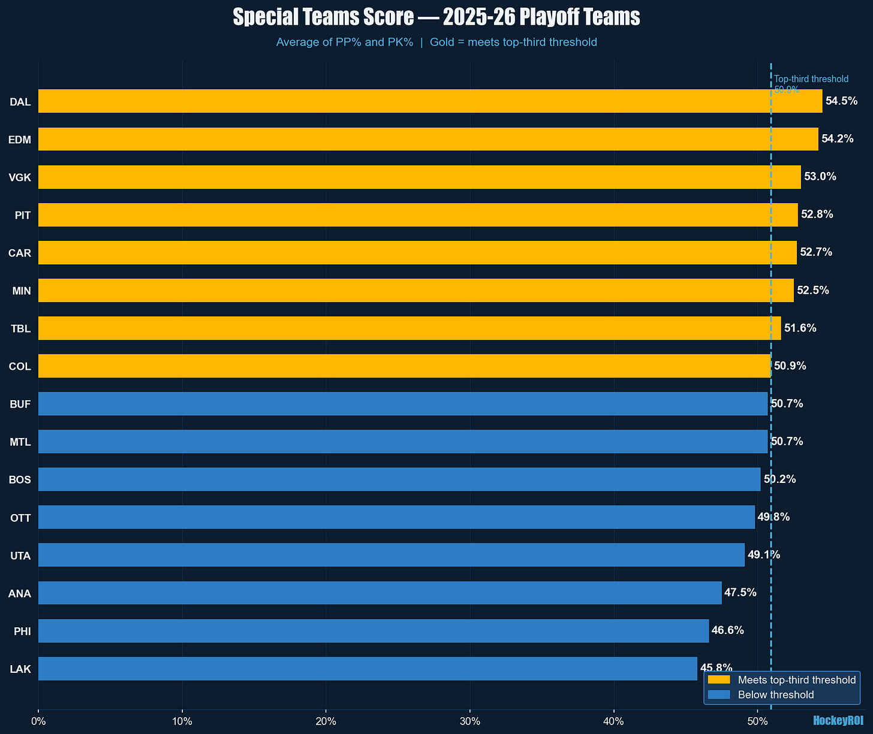

Special teams score for all 16 playoff teams. Gold bars meet the top-third threshold (50.9%). Edmonton and Dallas lead the playoff field. LA and Philadelphia are the weakest special teams teams in the bracket.

Three teams to watch for deep runs: Colorado, Carolina, Dallas. All three-pillar teams with elite net-front forward rosters and sustainable defensive structures. If the model is right at least two of these three are playing in May.
The series that tells us most about the model: Vegas vs Utah. If Utah wins, the three-pillar framework beats conventional wisdom. If Vegas wins, the new coaching system and Carter Hart were real factors the season-long data couldn’t capture.

Round 2 preview: The defensive suppression and goaltending models are currently being built from the same NHL API shot event database. Forward net-front framework is complete. Full data-driven predictions coming before Round 2 starts. The model gets sharper.

Model limitations: Even strength data plus PP% and PK% outcomes. 86% holdout accuracy means roughly one to two predictions here are wrong. System vs player effects not fully separable without tracking data. Full methodology at github.com/HockeyROI/nhl-analytics.
@HockeyROI on X | hockeyROI.substack.com

